

BUDGET COMMITTEE

MINUTES

Friday, February 5, 2010

PRESENT: Proctor Wentworth, John Skidmore, Tracey, Jean Routhier

VISITORS: N/A

CALL TO ORDER: Chairman Tracey McCormick called the meeting to order at 9:48 PM in the Hampstead Middle school after the Town deliberative session.

MEMBER’S COMMENTS/REPORTS: No reports

BUDGETS/WARRANT ARTICLES CHANGES REQUIREING A NEW VOTE:
According to a Warrant article passed in 2008 Each vote needs to be tallied an recorded.

Town Discussions/Clarifications for Articles- No one thought a discussion was required over changes.
Art. 2 Town Operating Budget
Art. 10 Revolving Recreation Revolving Fund

School Discussions/Clarifications for Articles
No changes were made requiring the Budget Committee to vote.

The chart below shows all required data for each vote.

TOWN BUDGET AND WARRANT ARTICLES THAT WERE REVISED

Article | On Motion by | 2nd | Abstained | Yes votes | No votes | Recommended  YES or NO and total vote
2 | Jean | Proctor | 0 | 4 | 0 | 4 Yes
10 | Proctor | John | 0 | 2 | 2 | 2 Yes 2 No

First meeting for New year -- Date: 4/8/10 Time: 7:00 pm Location: Selectman Office

ADJOURNMENT
On a motion from Jean, seconded by John, the meeting was adjourned at 9:50 pm.

For the Committee
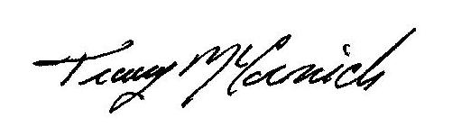
Chariman

